Website Development
Unit 3 assignment report / Seventies Sound / September 2026
This is a 3-page website introducing 1970s music to 17-23-year-olds. I used HTML, CSS and JavaScript.

Task 1: Research and planning

Brief, audience and research
The brief asks for a mobile-friendly three-page site with navigation, search, an accordion, video, image popups, external links, a request form and accessibility features. I wanted the site to work for someone who knows a song already and someone who has never listened to 70s music.
Site | What I noticed | What I used
TheGreat70s [1] | The image makes the decade obvious, but the advert uses too much room on a phone. | Clear heading and image, but no adverts.
ABBA [2] | The dark layout and large image are strong. It mainly suits people who already know ABBA. | Short introduction before a listening link.
Rock Hall [3] | Artist cards and search make browsing easy. Its phone layout feels busy. | Genre buttons and search, with one-column phone cards.
The research screenshots are saved in planning-and-research/research-notes. ABBA's history gave me the 1974 Eurovision fact. I used David Bowie for glam rock and Donna Summer for disco, with official pages and chart information for facts and dates. [4-7]

Content, copyright and accessibility
Decision | Reason
Seven artists from different genres | There is enough choice for a beginner, without making Explore hard to look through.
Official YouTube links and credited images | This avoids copying music files. Source and licence records are kept with the assets. [8]
Short request form | It only asks for a topic, type of idea and optional reason. The visitor sends it from their own email app. [10, 11]
Labels, alt text, captions and keyboard controls | These make the content easier to use with a keyboard, screen reader or without sound. [11]

Site map and page plan
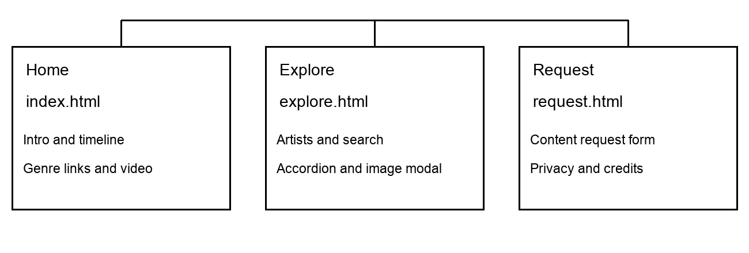
All three pages share the same navigation. Explore has genre shortcuts, and on a phone the links open inside Menu.
Page | Content and features
Home  index.html | Introduction, genre cards, short timeline and video with captions and written text.
Explore  explore.html | Artist cards, genre buttons, search, extra facts, larger photos and official listening links.
Request  request.html | Topic request form, privacy, credits and accessibility information.
Home is the starting point, Explore has the music and Request is for suggestions. Search ignores capital letters and extra spaces. If there is no result, the genre buttons are still there to browse from.

Sources
[1] TheGreat70s, homepage. https://thegreat70s.com/
[2] ABBA, official homepage. https://abbasite.com/
[3] Rock & Roll Hall of Fame, artist directory. https://rockhall.com/inductees/inductees/
[4] ABBA, The Story. https://abbasite.com/story/
[5] ABBA, In Focus: Dancing Queen. https://abbasite.com/articles/dancing-queen/
[6] Rock & Roll Hall of Fame, David Bowie. https://rockhall.com/inductees/david-bowie/
[7] Official Charts, I Feel Love - Donna Summer. https://www.officialcharts.com/songs/donna-summer-i-feel-love/
[8] GOV.UK, Using somebody else's intellectual property: Copyright. https://www.gov.uk/using-somebody-elses-intellectual-property/copyright
[9] ICO, Cookies and privacy notices in detail. Guidance marked under review. https://ico.org.uk/for-organisations/advice-for-small-organisations/privacy-notices-and-cookies/cookies-and-privacy-notices-in-detail/
[10] ICO, Children and the UK GDPR. https://ico.org.uk/for-organisations/uk-gdpr-guidance-and-resources/childrens-information/children-and-the-uk-gdpr/
[11] W3C, How to Meet WCAG 2.2. https://www.w3.org/WAI/WCAG22/quickref/

Task 2: Designs and assets
I kept the three pages from my plan. Georgia is used for headings and Arial for the main text, because both are easy to read. I used the same dark blue, gold and pale background on every page so it feels like one site.
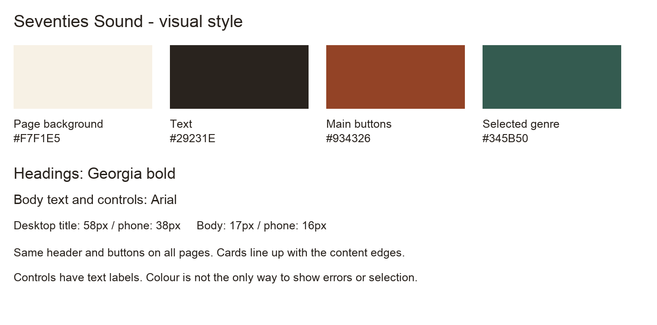
Colours and text styles used across the website.

Final page designs
The three designs below show the wireframe, finished desktop page and phone layout. Full-size versions are saved in website-design/page-plans and website-design/website.
Home  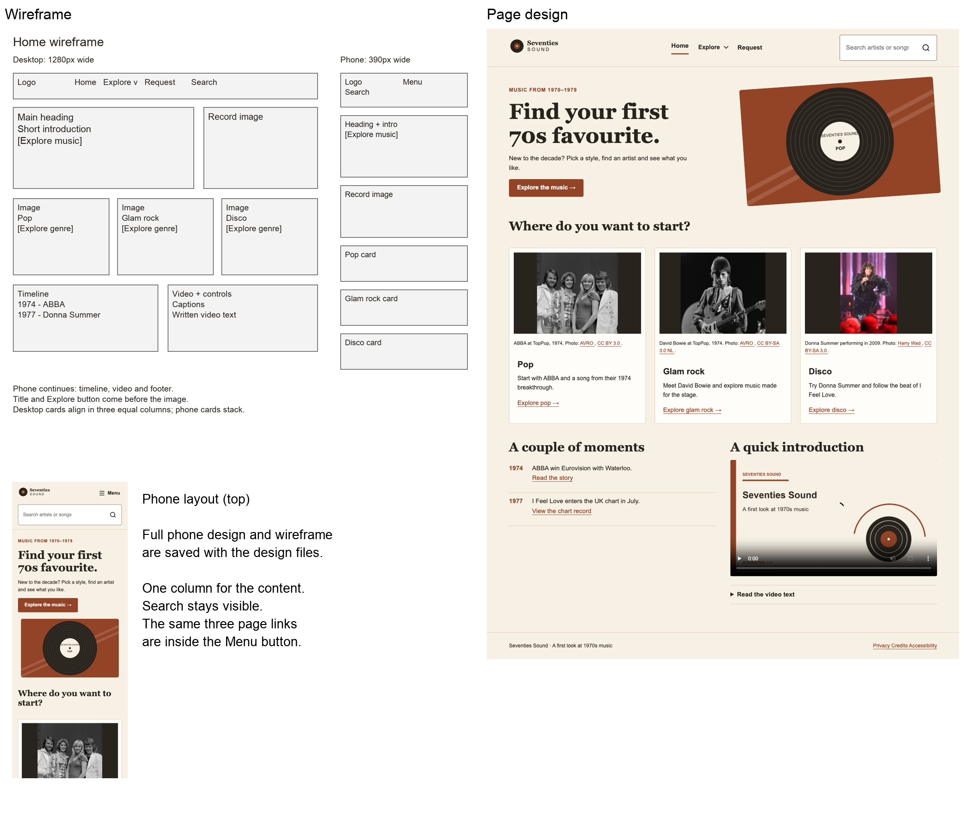 | Explore  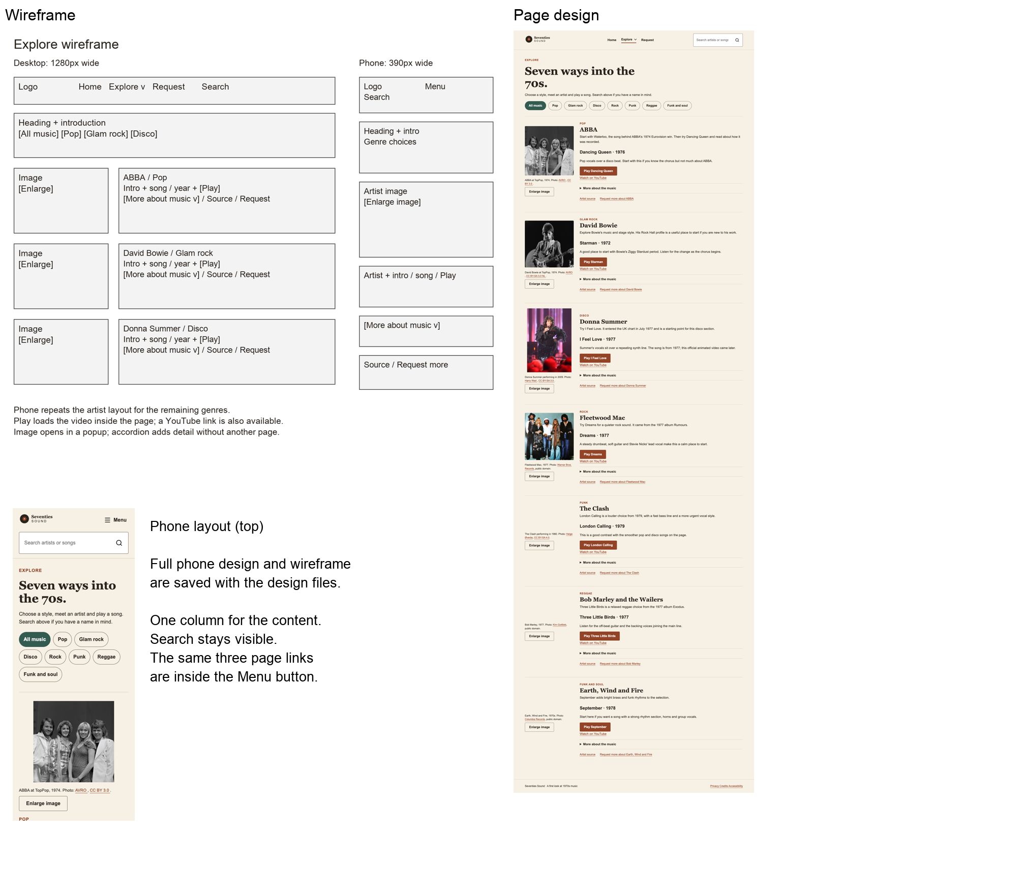 | Request  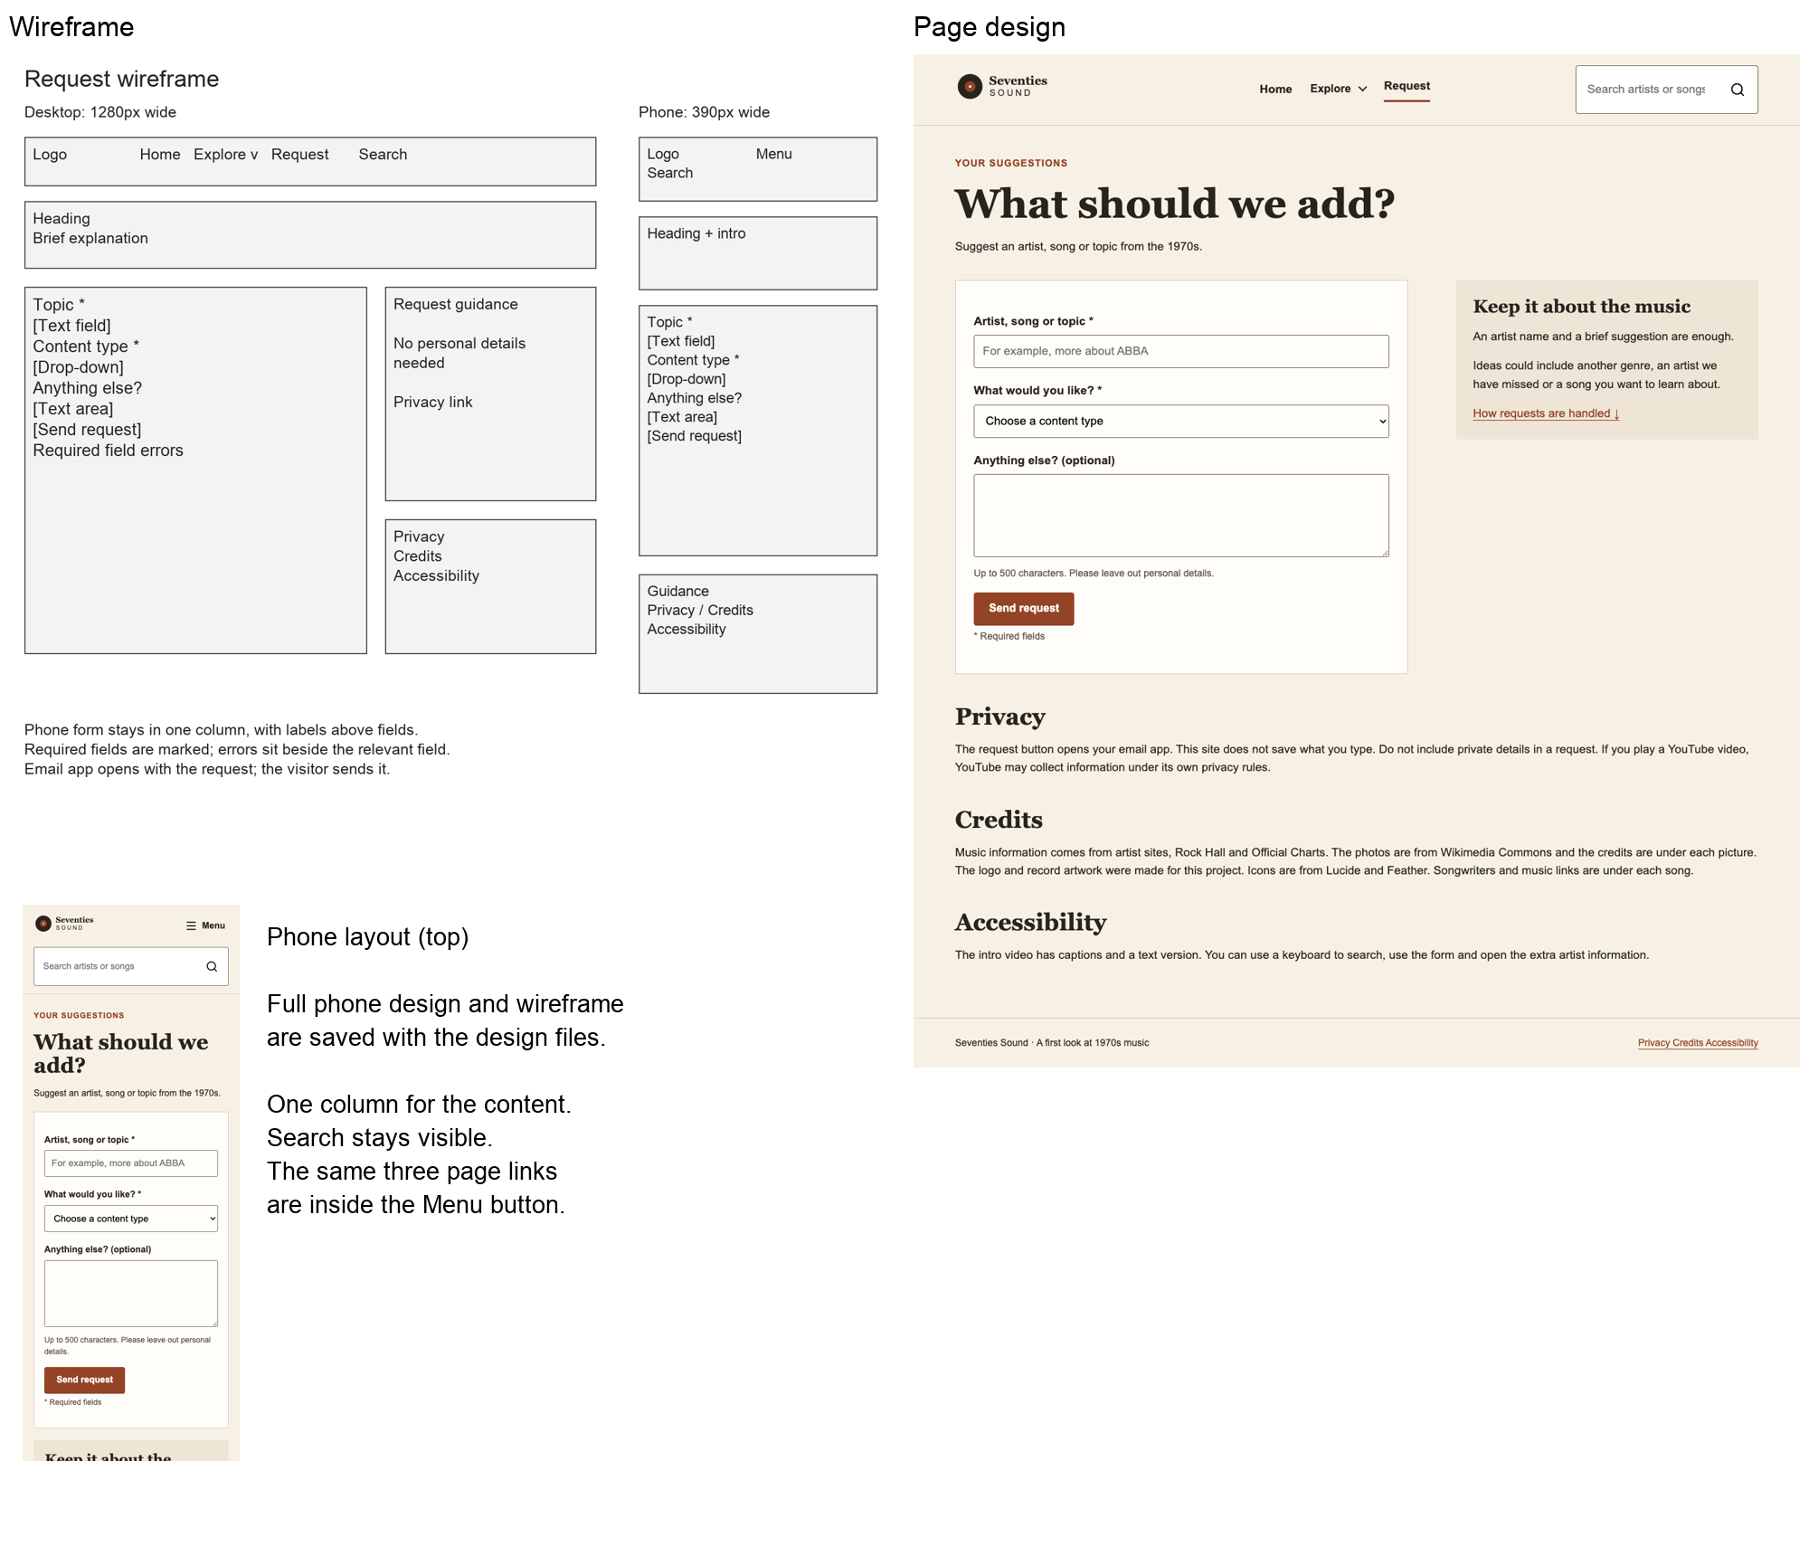
Home gives a quick way into the music. Explore keeps each artist, photo and song together, with extra facts hidden in accordions. Request uses a short labelled form. On a phone, the content becomes one column and the page links go inside Menu.

Important states
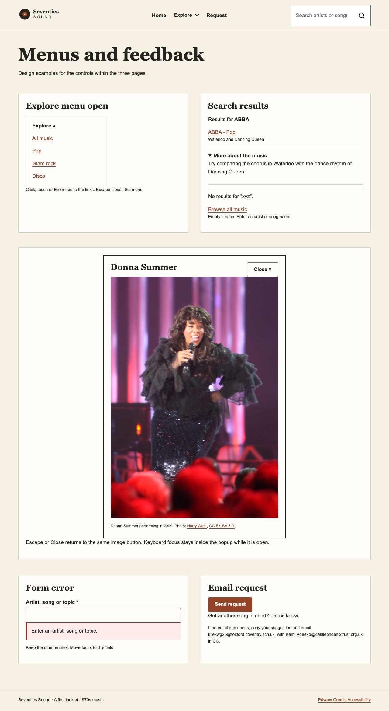
Drop-down, search, image popup and form messages.
The Explore menu links to each genre. Search stays on Explore. A blank search gives help and no matches gives a way back to all artists. The image popup has a Close button and keyboard support. The request button checks the required boxes, then opens a pre-filled email for the visitor to send.

Review and assets
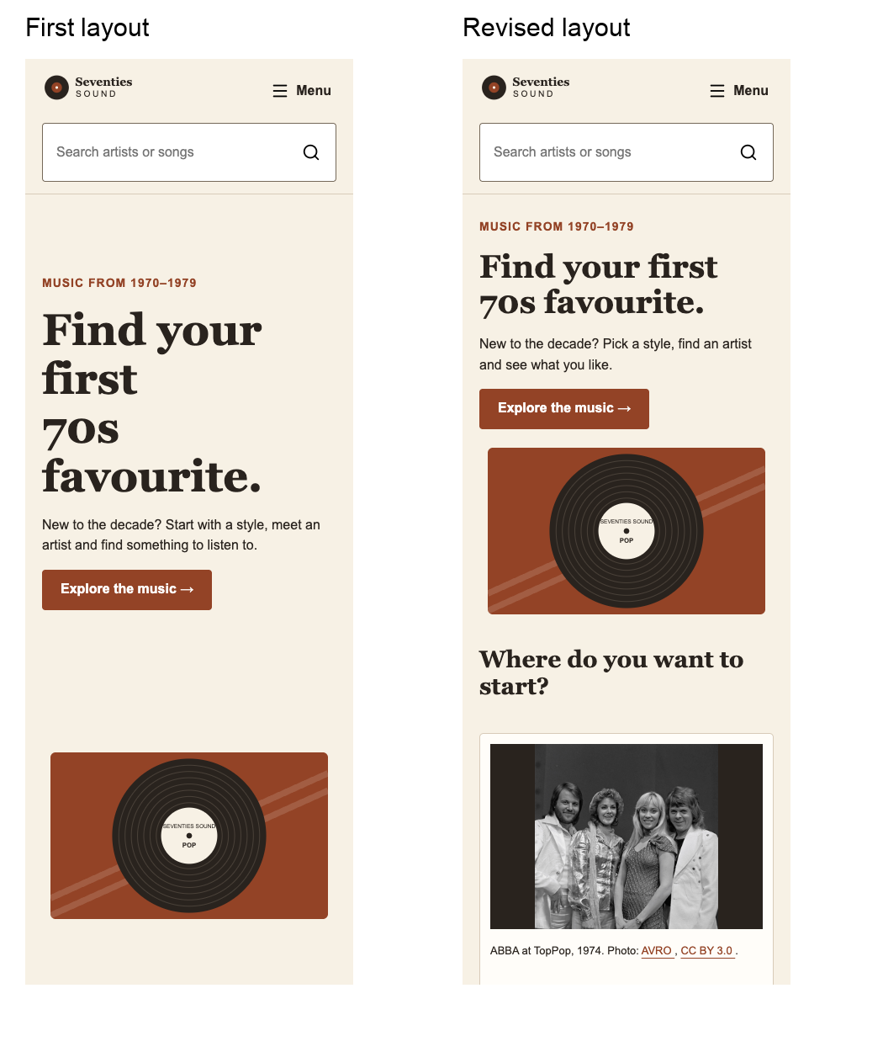
First Home phone layout compared with the revised layout.
In my first Home design, the heading and record took up too much room, so the genre cards were too far down on a phone. I made the heading smaller and removed the fixed height. The cards now appear much sooner.
The pages fitted both screen sizes and the links stayed in the same place. I also checked the popup with a keyboard. Explore has seven artists from different styles, and videos only load when someone presses Play.
The logo and record illustrations were made in Canva, then saved as SVG files for the website. I used credited artist photos, Lucide icons [12] and official YouTube embeds. The video has original title cards and script, an ElevenLabs voiceover, captions and a written transcript.
[12] Lucide licence: https://lucide.dev/license.

Task 3: Building and testing
I made the 3 pages in HTML, CSS and Javascript. I used one CSS file so the colours, fonts and links stay the same on each page. I kept the writing as normal webpage text, so it can be searched and read properly.
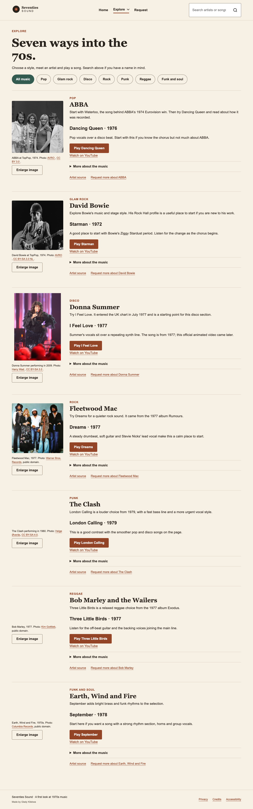
Explore page after building: search, genre choices, artist sections and listening links.
I kept all the artists on Explore because it is easier to look through them in one place. Search takes you there too. The genre buttons still work with search, so you can look for ABBA while keeping Pop selected. The request link checks the required boxes before it opens an email.

Changes made while building
I made the Explore button open a list of the music styles. On a phone, the Menu button puts the page links into one list. I also added a Skip to content link and made the keyboard outline easier to see. The photo popup has a Close button, works with Escape and sends you back to the same button when it closes.
The song videos only load after someone presses Play, so the page is not trying to load all of them straight away. I had a problem with YouTube in my first preview, so I used the localhost address in Live Server and it worked. Sources and credits open in a new tab, which means people do not lose their place on the site.

Functionality checks
I tried the pages on Edge on my laptop and at phone size. I also used the keyboard for the menu, Skip link and bigger-photo button. I checked the YouTube videos in my local preview as well.
Check | Result | What happened
index.html on a computer | Pass | Nothing went off the side of the page.
index.html on a phone | Pass | The page still fitted the phone screen.
explore.html on a computer | Pass | Nothing went off the side of the page.
explore.html on a phone | Pass | The page still fitted the phone screen.
request.html on a computer | Pass | Nothing went off the side of the page.
request.html on a phone | Pass | The page still fitted the phone screen.
Skip link | Pass | It took me straight to the main part of the page.
Explore menu | Pass | It opened, closed with Escape, then focus went back to the button.
Menu on phone | Pass | It opened and Escape closed it again.
Search and genre buttons | Pass | I could search for ABBA and then change the genre without it breaking.
Make image bigger | Pass | The picture opened bigger and Escape closed it.
Song video | Pass | Pressing Play put the YouTube video on the page. I checked the videos played in localhost too.
Request page | Pass | It would not make the email until I filled in the required boxes. Then it made the email with the client copied in.

Review
The main thing I changed was putting the artist information and song together on Explore. Before that, it felt like there were two separate lists. I also checked that the menu and photo popup worked with a keyboard, not just with a mouse. The three pages now have the same layout and navigation, and the parts I tested worked.

